EUROPEAN COMMISSION
SECRETARIAT-GENERAL
Recovery & Resilience Task Force
DG ECFIN
2022-01-28
DISCLAIMER: This is a document prepared by the Commission services. It provides technical guidance on how to use Arachne on the prevention of serious irregularities in the context of the Recovery and Resilience Facility. This guidance has not been endorsed by the European Commission.
Guidance note on the use of Arachne
- Introduction
Arachne is an integrated IT tool for data mining and data enrichment developed by the Commission in the context of the structural funds. Arachne’s main objective is to support national authorities in their administrative controls and audits with a view to protect the EU financial interests.
Arachne combined internal data on projects financed from the Union funds provided by the Member States with external publicly available data stemming from data basis such as WorldCompliance and Orbis. Arachne processes this data to identify linkages and calculates on that basis risk scores per project, beneficiary, contract and contractor. This allows to identify more easily those projects, beneficiaries, contracts and contractors that might represent a higher risk of fraud, corruption, conflict of interest and, to a lesser extent, double-funding.
National data is uploaded by the Member States directly from the national IT system(s) into Arachne. This can be done at any moment but the Commission recommends strongly to upload data at least every quarter in order to obtain the most recent risk calculations. The Commission provides support to assist the Member States in the development of an xml-file which matches national data to the Arachne data fields.
The access to the risk scoring results is also available for the Commission. It has also been agreed that Olaf and ECA have access, on a case-by-case basis, to that data which is subject to an audit or an investigation.
Art. 22(4) of the RRF Regulation mentions that “the Commission shall make available to the Member States an integrated and interoperable information and monitoring system including a single data-mining and risk-scoring tool to access and analyse the relevant data, with a view to a generalised application by Member States of that system including with support of the Technical Support Instrument”. In order to comply with this requirement, the Commission is performing an update of ARACHNE and ensured that the system can be used in the context of the RRF.
The objective of this document is to provide guidance to national authorities on the use of Arachne as a single data-mining and risk-scoring tool in the context of the RRF. This guidance does not intend to replace a specific IT training for users of the tool. In line with the conditions of the Charter on the use of Arachne, the Commission provides technical support and training to the Member States upon request.
- Recommended scope of application
The use of a single data-mining and risk-scoring tool to access and analyse the relevant data in the context of the RRF contributes to improving the control systems of the Member States, to strengthening fraud prevention and detection, and possibly to reducing serious irregularities. In addition, it facilitates the Member States’ continuous monitoring and provides an overview of the internal and external data regarding projects, beneficiaries and contracts/contractors.
It is highly recommended that implementing authorities include the use of Arachne in their management and control procedures for the purposes of risk analysis, red flagging and risk-scoring. Arachne can supplement but does not replace other ex-ante or ex-post controls and audits.
The use of Arachne can take place at various stages, for instance at project selection, contract award, project implementation, payments to the beneficiary, ex-post audits. It must be combined with other instruments such as self-declarations on absence of conflicts of interest. National authorities should also provide continuous, comprehensive and compulsory training on ethics and integrity and on how to identify, manage and monitor conflicts of interest. Asset disclosure and policies for certain exclusive functions and/or cumulative jobs for holders of public office or officials in sensitive/higher risk posts could also help prevent and detect conflicts of interest. The identification of sensitive functions or activities to assure effective separation of functions will also reduce the risk of conflict of interest. Member States should have the procedures in place to remove staff from the involvement and/or functions related to specific projects, calls or procedures in cases of confirmed conflict of interest.
Whistleblowing procedures should be in place and include elements such as what to report, how to report, to whom to report, where to find support, the protection of personal data, the protection measures for whistle-blowers, how their reporting will be investigated and communicated and the consequences for people who retaliate against whistle-blowers.
It is up to the authorities to decide how to integrate Arachne in their audit and control systems and at what stage of the implementation cycle of a project to use it. They can for example use it when applicants are selected following a call for proposals, when contracts are signed with final beneficiaries, when they make payments or as part of their ex-post audits.

- Arachne risk categories in the RRF context
As Arachne was developed in the context of structural funds, it includes data that is not all directly relevant for the RRF implementation. When assessing the risks associated to projects, Member States are recommended to pay close attention to the four serious irregularities identified in the RRF regulation, i.e. conflict of interest, fraud, corruption and double funding.
The table below provides the indicators that are particularly relevant for each of these serious irregularities. .
Serious Irregularities | Project risk category | Key project risk indicator to be verified | Secondary project risk indicator to be verified
Conflict of interest | Reputational & Fraud Alerts | Links between beneficiaries/ project partners  Links between beneficiaries/ project partners and contractors/ Consortium members  Links between beneficiaries/ project partners and subcontractors  Links between contractors/ consortium members  Links between contractors/ consortium members and subcontractors  Involvement in PEP lists | High rotation of directors
Fraud and corruption | Reputational & Fraud Alerts | Beneficiaries with invalid VAT number  Registration of multiple companies on same address  Inconsistent activities  Name or address changes  Involvement in sanction lists  Involvement in enforcement lists | High or deteriorating propensity to bankruptcy  Non filing of annual accounts  High or deteriorating rating compared to sector benchmark  High financial ratings of associated companies  Involvement of directors/owners with bankruptcies  Involvement of directors/owners in sensitive regions  Incorporation in sensitive regions  Group involvement in sensitive regions  Use of PO box address  Involvement in adverse media  Newly created company  New owners/directors  Activity changes
Double funding | Concentration risk | Beneficiaries involved in multiple projects  Beneficiaries involved in multiple Operational Programmes (OP) Partners involved in multiple projects  Partners involved in multiple OPs  Contractors involved in multiple projects  Contractors involved in multiple projects of the beneficiary  Contractors involved in multiple OPs  Consortium members involved in multiple projects  SubContractors involved in multiple projects

The risk categories (e.g. Concentration risk, Reputational and fraud alerts…) combine a set of coherent risk indicators and define the risk scoring for that particular risk category. Later on, all risk category scores are combined to provide the scoring for the project/beneficiary/contractor/contract, where applicable
For each of the serious irregularities, there is an associated project risk category that is linked to it and an associated project risk indicator. The key project risk indicators are those that are the most relevant from the detection of a specific serious irregularities.
Conflict of interest
Arachne provides assistance to national authorities for the detection of conflicts of interests by showing the links between beneficiaries, project partners, contractors, subcontractors and consortium members. It shows legal links (between companies) and private links (between companies and related people). Important links between the public authority and the beneficiary/contractor/subcontractor can be identified by Arachne through use of the database on Politically Exposed Persons (PEP).
It also identifies the projects for which there is related company or person which is listed as Politically Exposed Person in the WorldCompliance database. PEPs are persons who are exposed to particular risks because of the (political, judicial or administrative) prominent public functions they hold or have held. The check is performed (i) for each beneficiary, project partner, contractor, subcontractor and consortium member linked to the project/contract, (ii) for each management member of these companies and (iii) for each involved person and key expert linked to the project/contract.
Fraud and Corruption
Arachne can contribute to the detection of fraud and corruption by drawing the attention of the authorities to a number of elements.
- Beneficiaries with invalid VAT number: This check will validate the beneficiary VAT number through a 'structure check' and through the VIES web service of the Commission.
- Registration of multiple companies on same address: This indicator will identify projects for which there is a related company (beneficiary, project partner, contractor or consortium member) with an address on which multiple other companies are registered. This is an indicator to prevent fraud in case letterbox companies are created to conceal the true identity of the owner or owners.
- Inconsistent activities: This will identify projects for which there is a related company (beneficiary, project partner, contractor or consortium member) that is involved in many different activity sectors. For instance, a company registered as active in the sector of import/export that now implements a construction project under the RRF could be a signal of possible fraud.
- Name or address changes: This identifies projects for which there is a related company (beneficiary, project partner, contractor, sub-contractors or consortium member) for which the address or name has changed in the period starting three years before the start of the project eligibility period/contract and ending at the end of the project eligibility period/contract (or 'now' if the project is still open).
- Involvement in sanction or enforcement lists: The objective of this check is to identify projects for which there is a related company or person which is listed in sanction or enforcement lists in the WorldCompliance database.
Double Funding
The RRF regulation does not exclude the use of various EU funds for the same project but prevents the double financing of the same costs. Arachne helps identifying the projects drawing on several EU funds where a potential risk of double funding exists. It shows beneficiaries, contractors, subcontractor, partners and consortium members involved in multiple projects irrespective of their role in the various projects.
- Use of the results of the risk scoring
Once data has been entered into and been processed by the Arachne tool, the responsible authority is recommended in a first phase to analyse the results, per risk-indicator, in order to assess whether any high number of cases for certain risks point at possible systemic issues.
The risk scoring could, for example, demonstrate that, despite self-declarations by applicants stating that no other funding is received, the risk score shows that beneficiaries participate in multiple research projects in multiple Operational Programmes (even in different Member States) under the Cohesion policy. The analysis of the results could thus point at inaccuracies of these self-declarations which may merit scrutiny, e.g. with the relevant Operational Programme authorities. These type of verifications could point out systemic issues in the application assessment process and would require possible amendments.
In a second phase, after the overall analysis of the results, projects/beneficiaries may be checked for the presence of high scoring risk indicators. It is recommended that the ‘key risk indicators’ as listed in the table above are verified, should they yield high scores. The reason being that these risk indicators point directly either at the presence of high risk, e.g. links between beneficiaries and contractors, or point at historic risky behaviour of beneficiaries/directors/mandate holders etc. which may require a prudent approach towards e.g. the payment of (large) advances.
As to what concerns the red flags generated by the ‘secondary risk indicators’, the Commission recommends that even if there are no key risk indicators red-flagged, the project should be closely verified when 4 or more secondary risk indicators are red-flagged.

By flagging possible risks, Arachne can help National authorities in performing their controls and audits for the implementation of the RRF. However, it does not supply with any proof of error, irregularity or fraud. Arachne does not aim at assessing the particular individual conduct of fund recipients and does not as such serve to exclude automatically any beneficiaries from the funding. The risk scoring cannot and should not lead to any automated decisions of exclusion or elimination of projects or beneficiaries.
Member States are free to set their own parameters in line with e.g. their fraud risk assessment analysis and their internal management and control procedures. Depending on the nature of the risk identified, the Member State needs to organise the appropriate checks.
The use of the results of Arachne will depend on the stage of the implementation.
When Arachne is used for the selection of beneficiaries or before the signature of a contract, the presence of a high risk score or red flag does not prohibit signing the contract but can provide important information to help guide preventive/corrective measures. Where for example, Arachne highlights that the beneficiary is receiving substantial funding from other EU funds for the same project, the authority may want to obtain more explanations on the costs financed through the different instruments.

When Arachne is used before the payment, the Member State may check the financial viability of the applicants via the proposed checks under fraud and corruption in Arachne, notably through indicators such as “High or deteriorating propensity to bankruptcy” or “High or deteriorating rating compared to sector benchmark”. Member States can use this information to request additional information or assurance from the possible beneficiaries.
Member States may usefully use Arachne as part of their audit strategy. In order to better target their audits, audit bodies can select projects having high scores in one or other area (e.g. double funding) to find potential cases of serious irregularities. Any findings of irregularities cannot be extrapolated to the whole population since the initial selection of the sample is done on a risk basis rather than randomly.
Member States are not required to mention the results of their use of Arachne in the payment requests. Member States are however encouraged to add this information separately if they so wish. The audit summary may represent a useful source of information for the Commission services on the use of Arachne.

- Next steps
An update of Arachne is planned in Q1 2022 to add a new feature to help analyse the data fields on beneficial owners. In the meantime, Member States can use Arachne to identify risks and help prevent serious irregularities and upload the data relating to the beneficiaries or to the contractors in the context of the RRF. There is already an additional data field in place for that effect in the tool where the names of the beneficial owners can be uploaded and stored, whilst this new feature is finalised.
Member States are invited to provide their feedback on their use of Arachne. The above guidance will be updated to take into account this feedback and the experience gathered with the implementation of the RRF.

ANNEX
Overview of the main information and functionalities in Arachne
By combining internal data on projects financed from the Union funds provided by the Member States with external publicly available data (WorldCompliance and Orbis), Arachne calculates risk scores per project, beneficiary, contract and contractor, hence enabling to identify more easily those projects, beneficiaries, contracts and contractors that might represent a higher risk of fraud, corruption, conflict of interest and, to a lesser extent, double-funding.
Data upload and use of data
The data available in the application comes from multiple sources and is aggregated in order to give the user a view on potential risks linked to the projects in his/her Recovery and Resilience Plan (RRP). These data sources are:
- Member States data about projects, contracts and, should the Member State choose to do so, on expenses. These are called “internal data”.
- Publicly available information about companies and their board members
- General information (address, phone, web site ...)
- Financial information coming from published balance sheets
- Ownership information between companies
- Ownership and functional relationships between companies and individuals
- Global PEP lists
- Global sanction lists
- Global enforcement lists
- Global adverse media lists
This publically available information is called “external data”. It is also referenced as “Orbis data” and/or “WorldCompliance data” in the manual or the application (Orbis and WorldCompliance are the original data source names).
“Vadis predictive indicators”, such as indicators “High or deteriorating propensity to bankruptcy” are based on predictive risk modelling. These indicators are considered to be external data as well. All these sources are bound and processed together in a single database, to allow the user to browse, search and perform advanced operations in the application. Arachne processes this data to identify linkages and allows the user to browse, search and perform advanced operations in the application.
The internal data should be uploaded in this system on a regular basis by the Member State. The external databases (Orbis and WorldCompliance) are currently refreshed on a quarterly basis but the intention is to refresh on a monthly basis as of Q2 2022.
The data to be uploaded by the Member States can come from data monitoring information systems established at Implementing or Managing Authority level that contain in particular the mandatory data to be to recorded and stored in electronic system on each operation/beneficiary for the purpose of audit and control, c.q. the data listed in Art. 22(2)(d) of the RRF regulation.
Personal data protection
On 17 May 2013, the European Commission submitted to the European Data Protection Supervisor (hereinafter: EDPS) the required notification concerning the processing of personal data through ARACHNE. The EDPS issued on 17 February 2014 (reference 2013-0340) a positive opinion concerning the compliance of ARACHNE with the provisions of Regulation (EC) 45/2001, and conducted an inspection on 30 June and 1 July 2016 at the premises of the Commission services, to investigate the follow-up of, and ensure compliance with, the recommendations by EDPS. In general, data provided by one Member State into ARACHNE will only be available to the Commission and that Member State. Such data will neither be shared directly with other Member States, nor with ARACHNE’s data providers.

Risk indicators and scores
Arachne is providing an overall risk score by project, beneficiary, contract and contractor, which is the average of 7 risk indicator scores, calculated for each of the following risk indicators:
- Procurement Overall Score
- Contract Management Overall Score
- Eligibility Overall Score
- Performance Overall Score
- Concentration Overall Score
- Reasonability Overall Score
- Reputational & Fraud Alerts Overall Score
Each risk indicator score varies between 0 and a predefined maximum value that represents the highest risk level. The risk indicator score gives a value for different criteria applied on projects, contracts, beneficiaries and contractors. It is represented by a numerical value and a LED style indicator that goes from green (no risk) to red (highest risk).
A score out of 50 is calculated based on the average of the individual risk indicators with the highest scores. The table below provides an overview of the calculation of how each risk indicator is calculated. Not calculated scores are represented by a – (minus) sign, and a grey LED representation. It means that either the risk indicator / category is out of scope for the project/contract, or the internal data required to calculate the risk indicator are not provided to Arachne. The risk score of a beneficiary is the weighted average of the risk scores of its projects. The risk score of a contractor is the weighted average of its contracts. This information is available on the Arachne User Manual, which is accessible from Arachne’s home page.
Procurement | A score out of 50 is calculated based on the average of the 3 individual risk indicators with the highest scores. Category risk score = (sum of the 3 risks with the highest scores / 30) * 50
Contract management | A score out of 50 is calculated based on the average of the 5 individual risk indicators with the highest scores. Denominator = sum of the max scores of the calculated risks of the 5 highest scores, but with a minimum of 30 Category risk score = (sum of the 5 risks with the highest scores / denominator) * 50
Eligibility | A score out of 50 is calculated based on the average of the 5 individual risk indicators with the highest scores. User manual 135 Denominator = sum of the max scores of the calculated risks of the 5 highest scores, but with a minimum of 30 Category risk score = (sum of the 5 risks with the highest scores / denominator) * 50
Performance | A score out of 50 is calculated based on the average of all individual risk indicators. Denominator = sum of the max scores of the calculated risks (without minimum) Category risk score = (sum of the calculated risks / denominator) * 50
Concentration | A score out of 50 is calculated based on the average of the 5 individual risk indicators with the highest scores. Denominator = sum of the max scores of the calculated risks of the 5 highest scores, but with a minimum of 30 Category risk score = (sum of the 5 risks with the highest scores / denominator) * 50
Reasonability | A score out of 50 is calculated based on the average of the 5 individual risk indicators with the highest scores. Denominator = sum of the max scores of the calculated risks of the 5 highest scores, but with a minimum of 30 Category risk score = (sum of the 5 risks with the highest scores / denominator) * 50
Reputational & Fraud | A score out of 50 is calculated based on the average of the 10 individual risk indicators with the highest scores, taking into account the weight of the individual indicators to identify the 10 highest risk scores (e.g. 6 on 10 is higher than 7 on 20 and lower than 4 on 5). Denominator = sum of the max scores of the calculated risks of the 10 highest scores Category risk score = (sum of the 10 risks with the highest scores / denominator) * 50
Overall | The overall score is the average of the scores of the categories mentioned above.

In order to find potential risks of irregularities, Arachne matches the internal (EC) data subjects with the external (Orbis and WorldCompliance) data subjects in order to enrich the internal data and to calculate the corresponding risk indicators. The matching is performed on ‘cleaned’ names, VAT numbers, addresses and birthdates. An exact match means that both cleaned full names contain exactly the same words. When an exact match is not found for a name, a fuzzy (=approximate string) matching technique is applied. For the matching of personal names the birthdate of the person can help to improve the matching quality. The threshold for fuzzy matching can be lower when two names are similar and they share the exact same birthdate (same year, same month, and same day). No match will be made between entities that have available but different birthdates.
The risk identification of serious irregularities are detected through each project score category available under Historical Risk Indicators. By right-clicking on the score, you can find more information on how those indicators have been calculated, as well as the references and links used to calculate the given score. It is possible to display the evolution of risks for a specific entity in an overview graph, by choosing “Risk evolution” from the contextual menu that can be expressed in weeks or months.
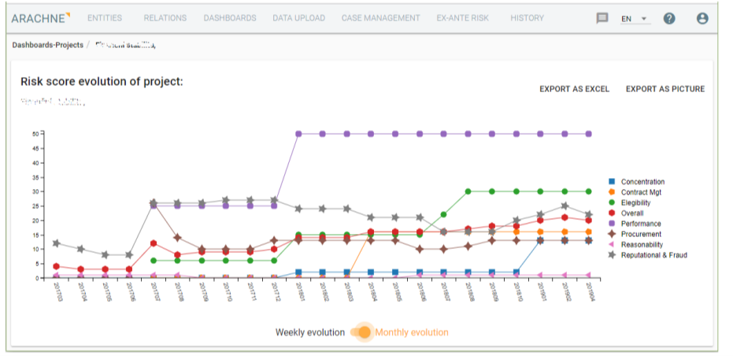

Project analysis
In order to help to identify and prevent irregularities, Arachne proposes different views, such as the Group view, to identify the risks associated to the projects, and shows the various links between companies and individuals. In the prevention of conflict of interest, the contracting authority could verify the links between companies before awarding a contract. The Group view of a particular project displays information about how groups are linked together through their respective company legal links. The network composed of companies and legal links is processed by a clustering algorithm to discover sets of strongly linked companies. From there, companies belonging to these groups are linked to them through the membership relation. These memberships give the ability to detect common shareholders or subsidiaries, main shareholder of a group, as well as various group indicators. Those links can help identify potential cases of conflict of interest, fraud or corruption. Arachne also contains an ‘ex-ante’ module capable of analysing automatically these risks related to applicants. Member States can therefore choose to upload (automatically) the names and identification numbers of applicants and process it through the Arachne system. This avoids manual verifications and provides more targeted views on potential risks.
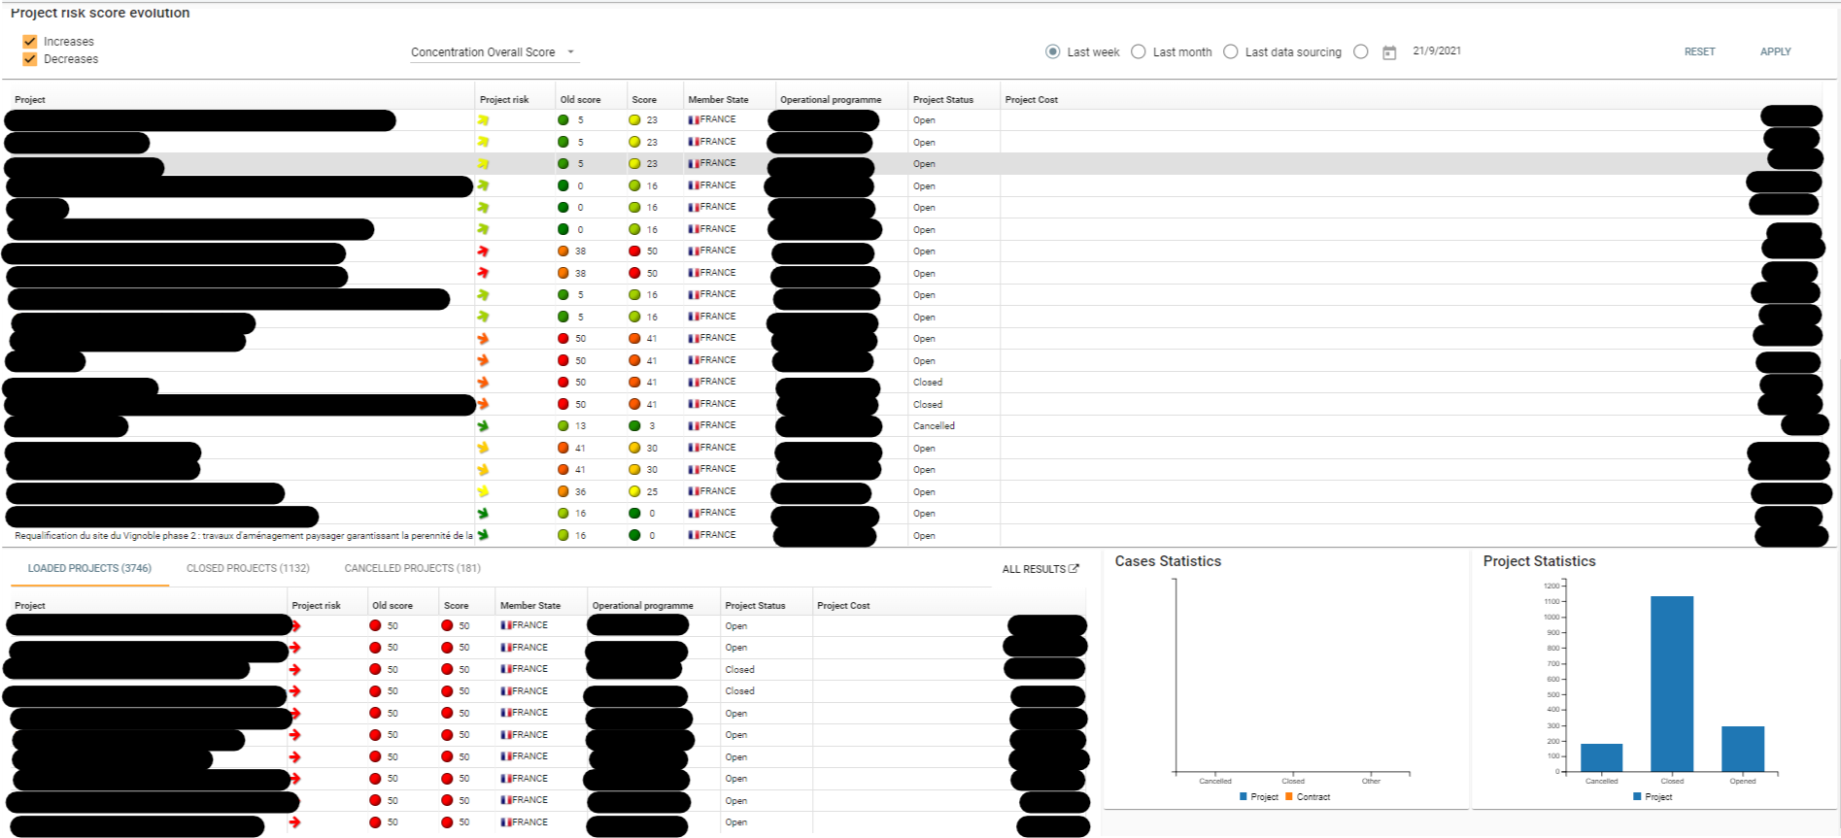
Project risk score evolution shows the top 10 of projects with the highest increase in overall (or selected category) risk score (if “increase” risk score selected) and the top 10 of projects with the highest decrease in overall (or selected category) risk score (if “decrease” risk score is selected).
Practical example of a case in Arachne
In this first example of a project, we identify that the alert summary gives a low overall score of 23. However, we can already identify a high risk in the concentration risk individual score, denoted by the red score of 48. This will be the starting point of our analysis.
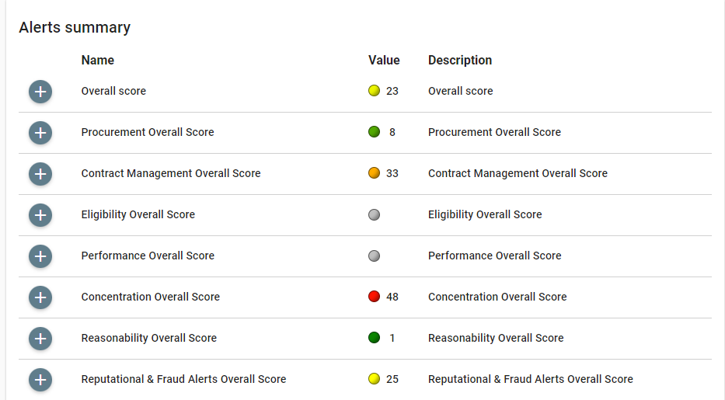
When examining the origin of the overall score of 48, we can see that it is composed of the following red indicators (“red flags”): Beneficiaries involved in multiple projects, Beneficiaries involved in multiple Ops, Contractors involved in multiple projects, Contractors involved in multiple projects of the beneficiary and Contractors involved in multiple Ops. These would need to be examined further by the implementing body or national Authority.
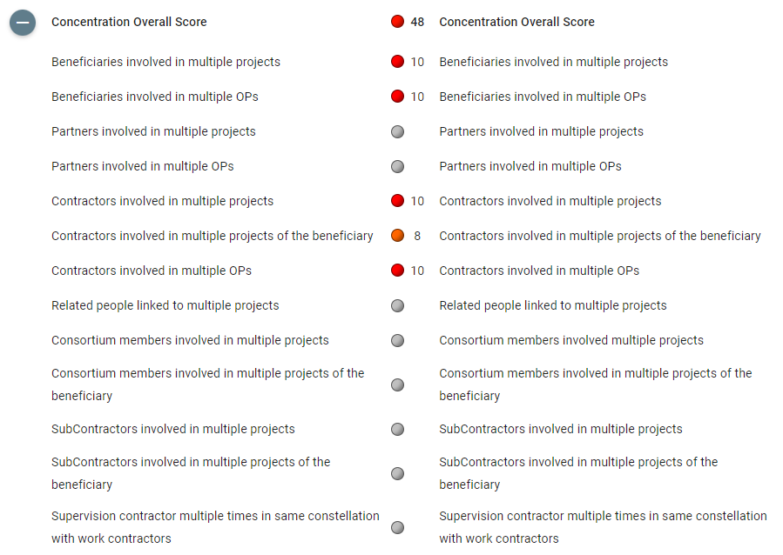
On closer inspection of the first risk indicator, beneficiaries involved in multiple projects, Arachne provides details about the beneficiaries involved in those projects, and thus helps to identify the possible presence of double funding. Arachne gives the possibility to view beneficiaries that are involved in multiple projects in different Operational Programmes and in different European countries, which goes beyond the possible verifications at the Member State level.
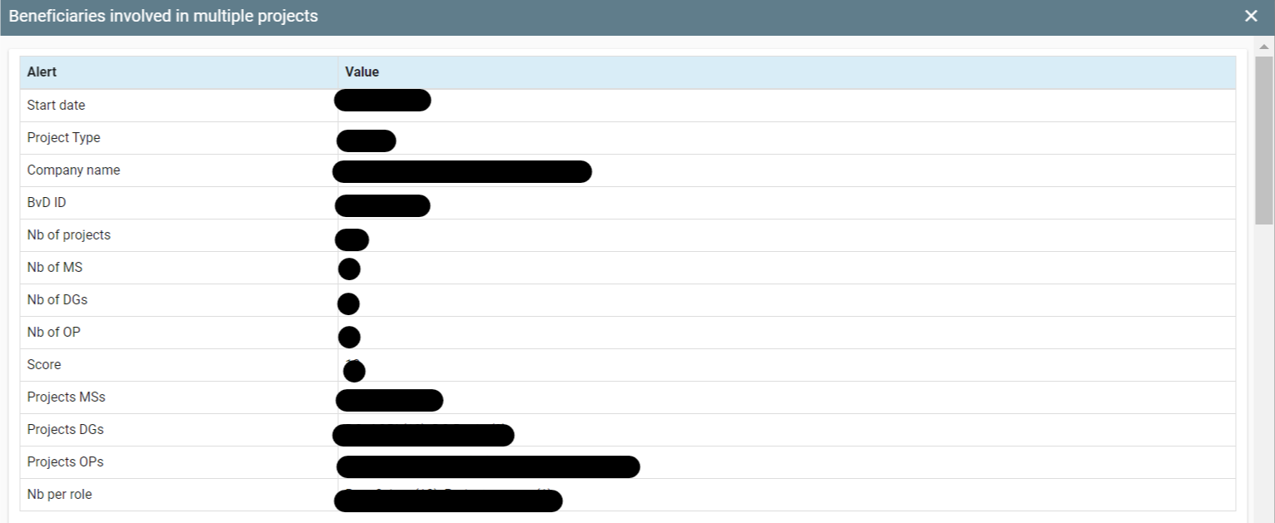
Considering the last item of the summary report, the Reputational & Fraud Alerts Overall Score shows that even though the overall score is a comparatively “low score” of 25, some individual risk categories can still be high and should be considered. In the screenshot below, the indicator “Registration of multiple companies on same address” (one of the pertinent indicators in the table above) appears in red, which means that it is recommended to be verified.
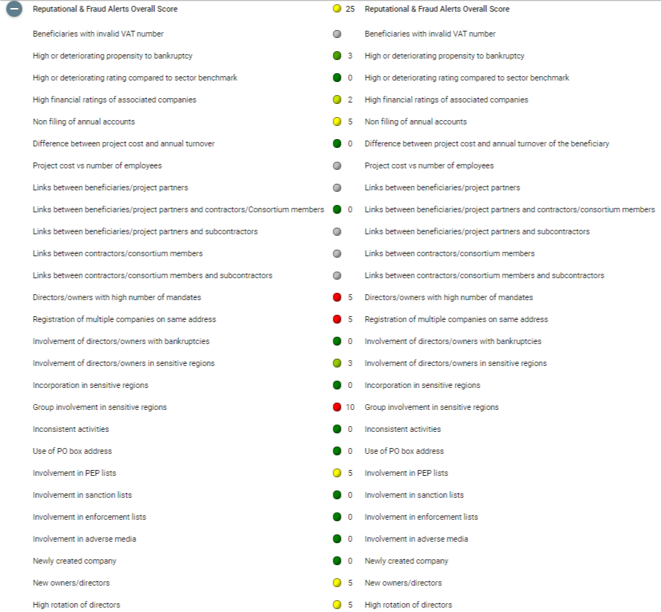
Arachne provides us the information below, i.e. the number of companies registered at the same address and their respective roles in the project. This information could indicate a risk and the implementing body may consider requesting further information or initiate an investigation by the national authorities before proceeding further.
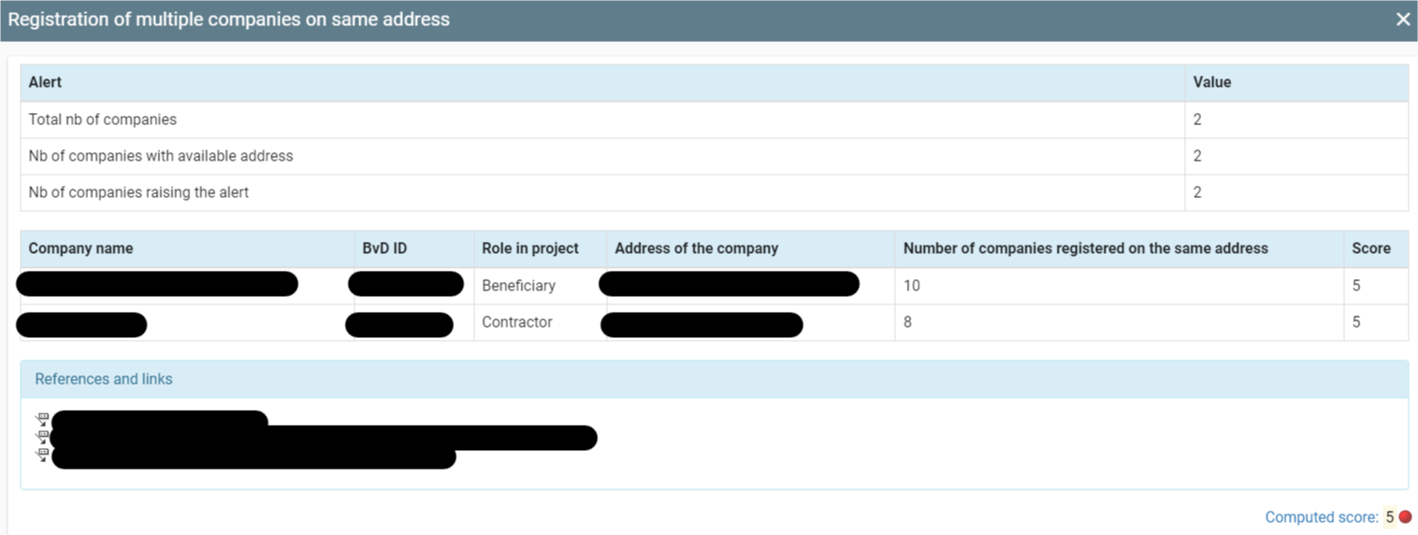

Please refer to the ARACHNE website https://ec.europa.eu/social/main.jsp?catId=325&intPageId=3587&langId=en for more information or contact directly the ARACHNE support team at: EC-DAC1-SECRETARIAT@ec.europa.eu
These multiple Operational Programmes will also contain the RRF of the Member States, the EAFRD programmes where applicable, the HOME and MARE funds.
Names can differ between the two databases. Arachne creates a match between the names received from Orbis and the internal data received from MS via ‘fuzzy matching’. This means that a comparison is made between the two names and if only a space or a typo would be the cause of the difference, Arachne will consider the names equal.

